# Hospital Management System

# User Guide

## Overview

In this application there are four types of user, each with different functionalities available to them:

* Administrators
* Secretaries
* Patients
* Doctors.

On creation of an account, a new user will choose a password and be assigned a unique ID based on their account role. This is the information they will need to log in.

## Administrators

Admin accounts are the only accounts with permissions to add or remove doctor and secretary accounts. On login they are presented with this screen, which displays a management dashboard with all relevant information and functionality presented to them:

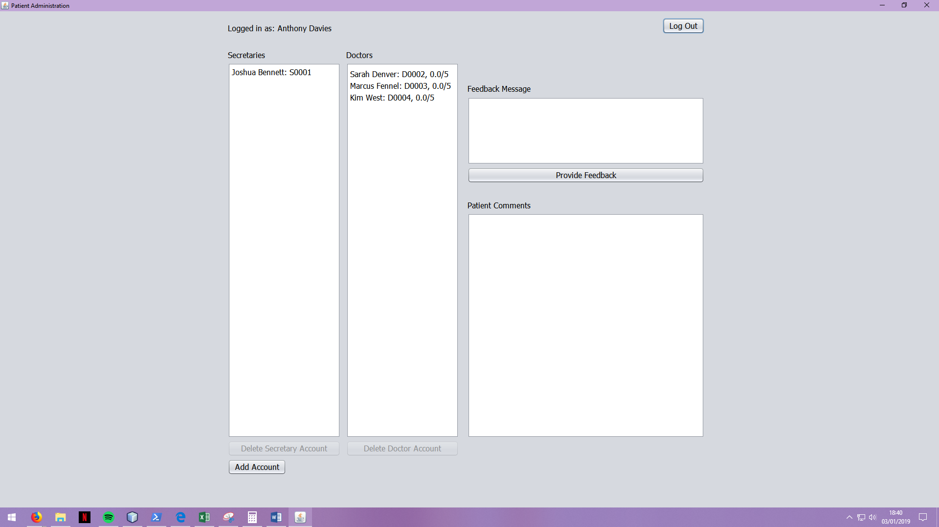

Clicking on “Add Account” will lead them to a form that gathers the basic information required to create a new account. As an administrator, the account creation will not need to be authorised where patient accounts will.

On selection of a secretary or doctor from the respective lists, the relevant “Delete Selected Account” button will be enabled.

Additionally, on selection of a doctor account the box for “Patient Comments” will automatically fill with a list of any feedback that doctor might have received.

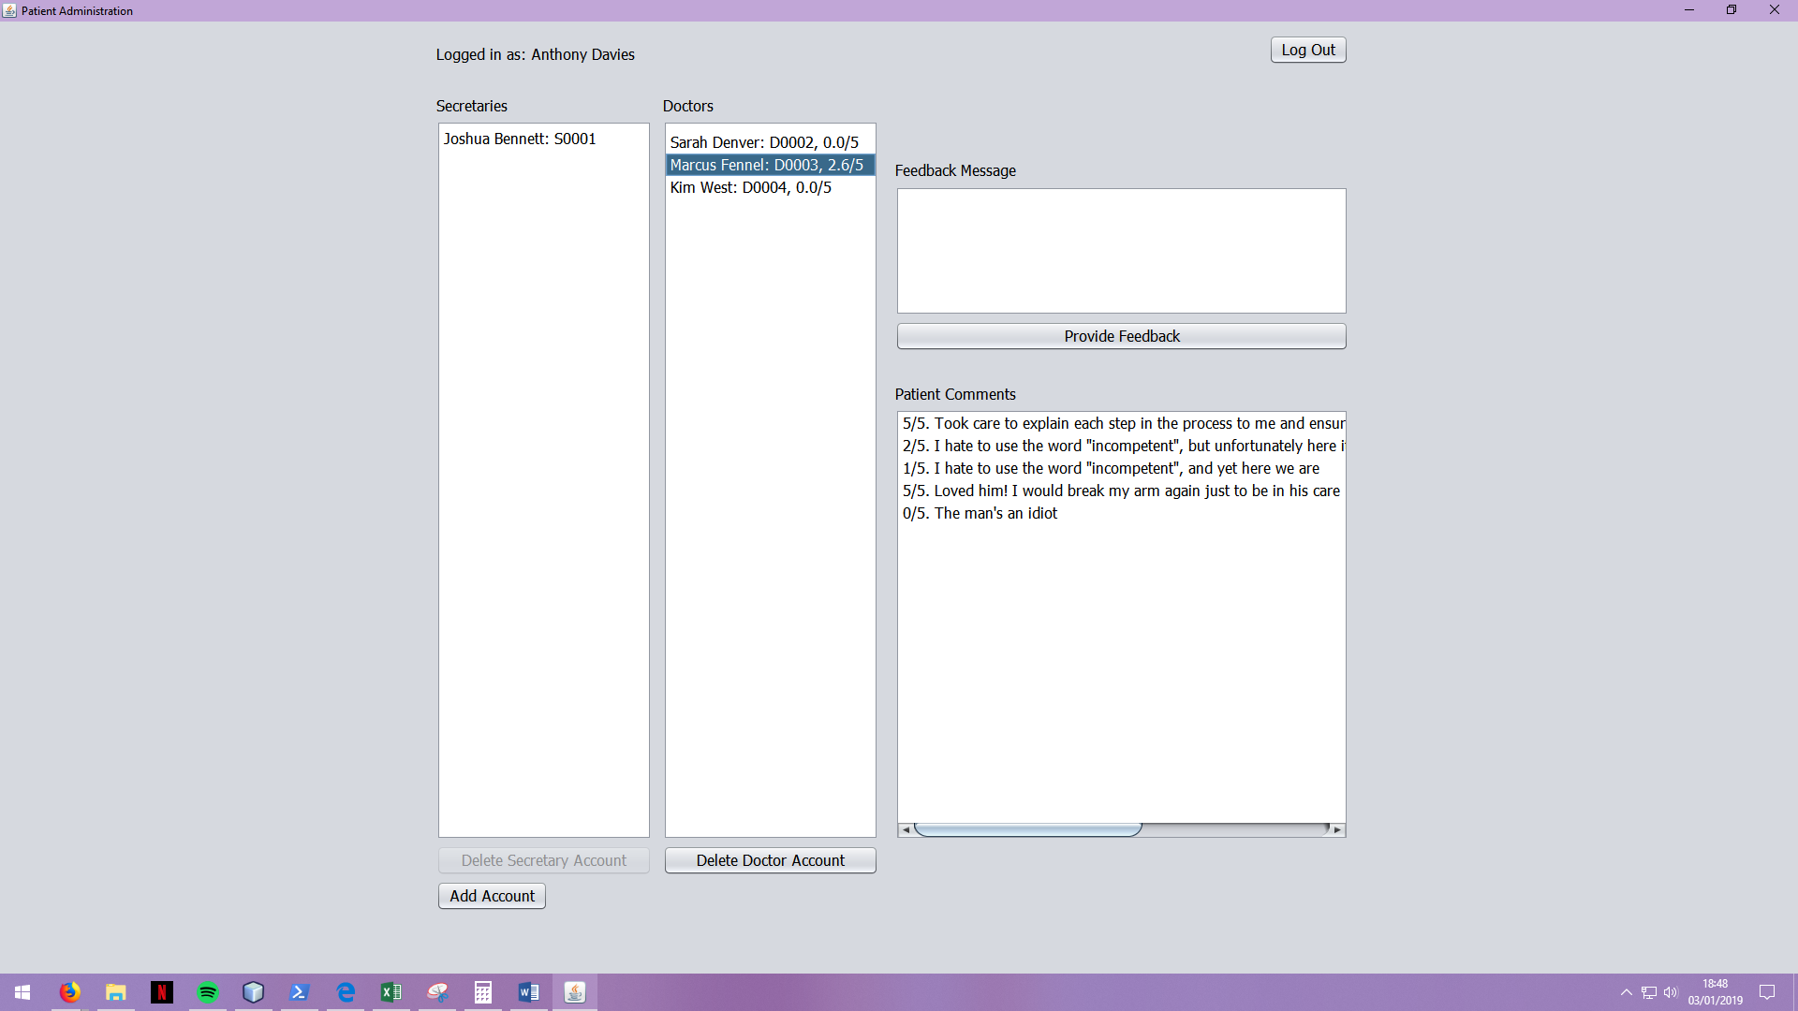

With a doctor selected, the administrator also has the option to send the doctor a message (via notification) based upon this feedback. This message will be displayed the next time the doctor logs in to the system.

## Secretaries

A lot of the functionality in the system goes through the secretaries. On login, they are presented with this dashboard:

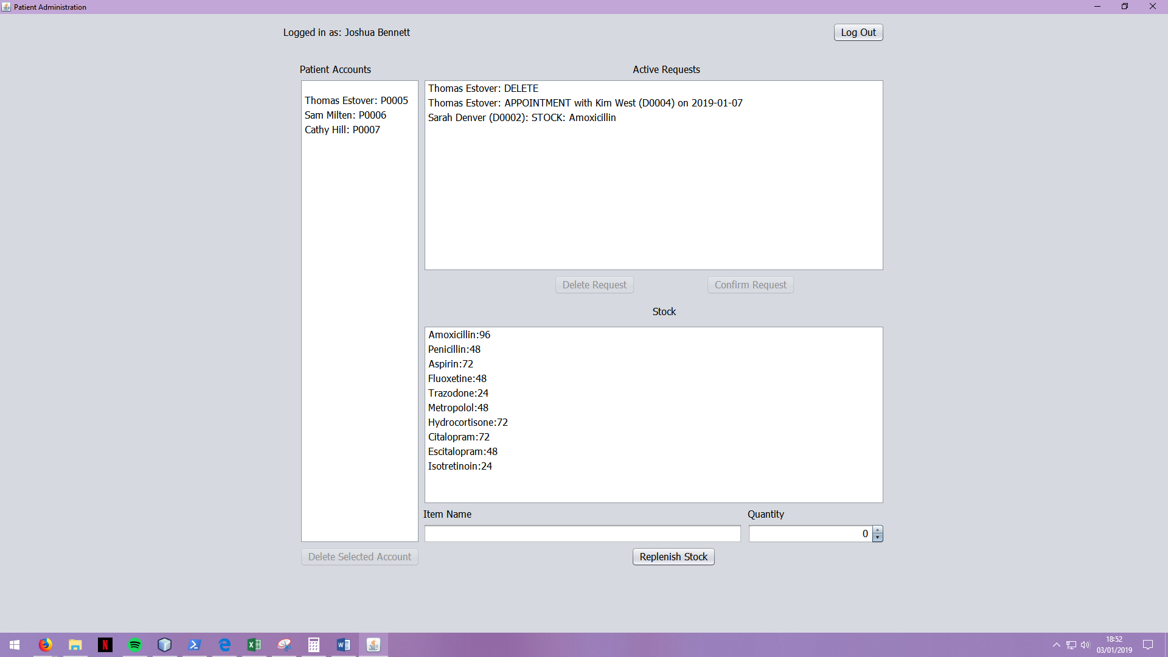

Their primary function comes from the ability to authorise requests. These are all presented in the same format: The requesting account, the type of request, and then any additional information needed. On authorising all requests bar appointments, the secretary is presented with a confirmation message as the system automatically handles it. For appointments, the secretary is presented with a different screen:

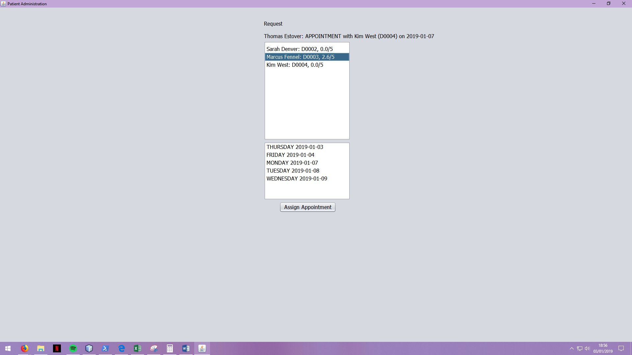

Here the secretary is required to select a doctor and a date from that doctor’s availability. The selected request is kept at the top for the secretary to try and match dates as close to the patient’s choices as possible. Once a date is confirmed, the secretary is presented with a confirmation message and the view returns to their dashboard.

The secretary also can manage stock. When a prescription request comes in, it can only be authorised if there is enough of the required medicine in stock. Therefore, the secretary is given an avenue to replenish stock underneath the list of stock items.

## Patient

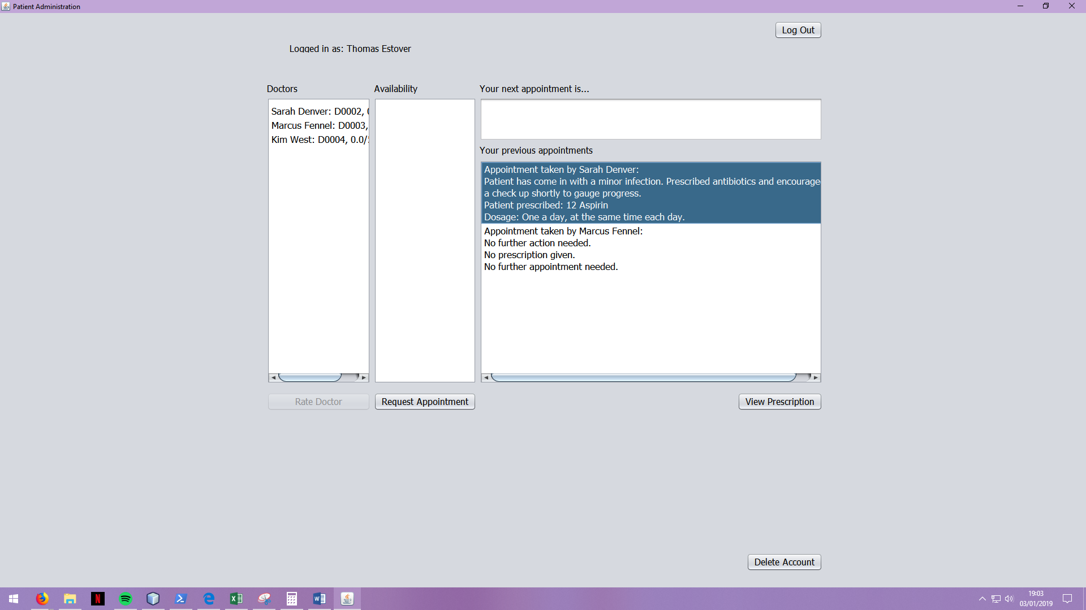

Here is a view of the patient’s managements dashboard. On the far left is an avenue for patients to view doctor’s and their ratings, as well as to provide feedback to one selected. On selecting a doctor, the next column along will also fill with a list of that doctor’s availability. From there the patient will be enabled to select a date and request an appointment.

Once this request is confirmed and the patient has an active appointment, the box in the top-right will fill with a reminder of the date and doctor linked to their appointment. Once an appointment is complete, a new history item will be added to the list below here with a summary of the appointment.

If following an appointment, a patient is given a prescription then a new request will be generated. On authorisation (which would occur when the patient visited the secretary to collect the prescription) the “View Prescription” button will be enabled.

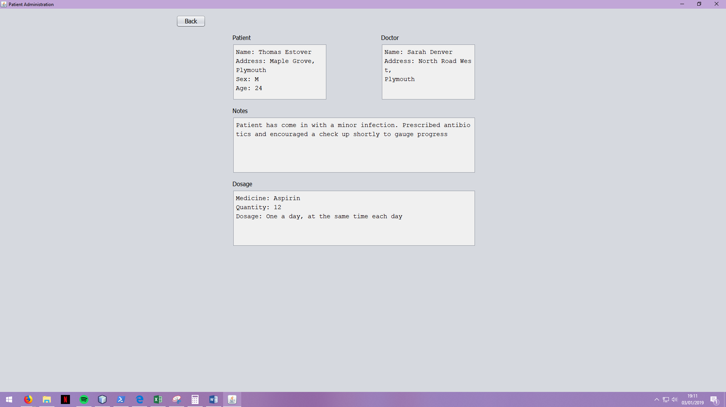

On clicking this, the patient will be presented with a summary of their prescription as such.

Finally, the patient can provide feedback to a selected doctor:

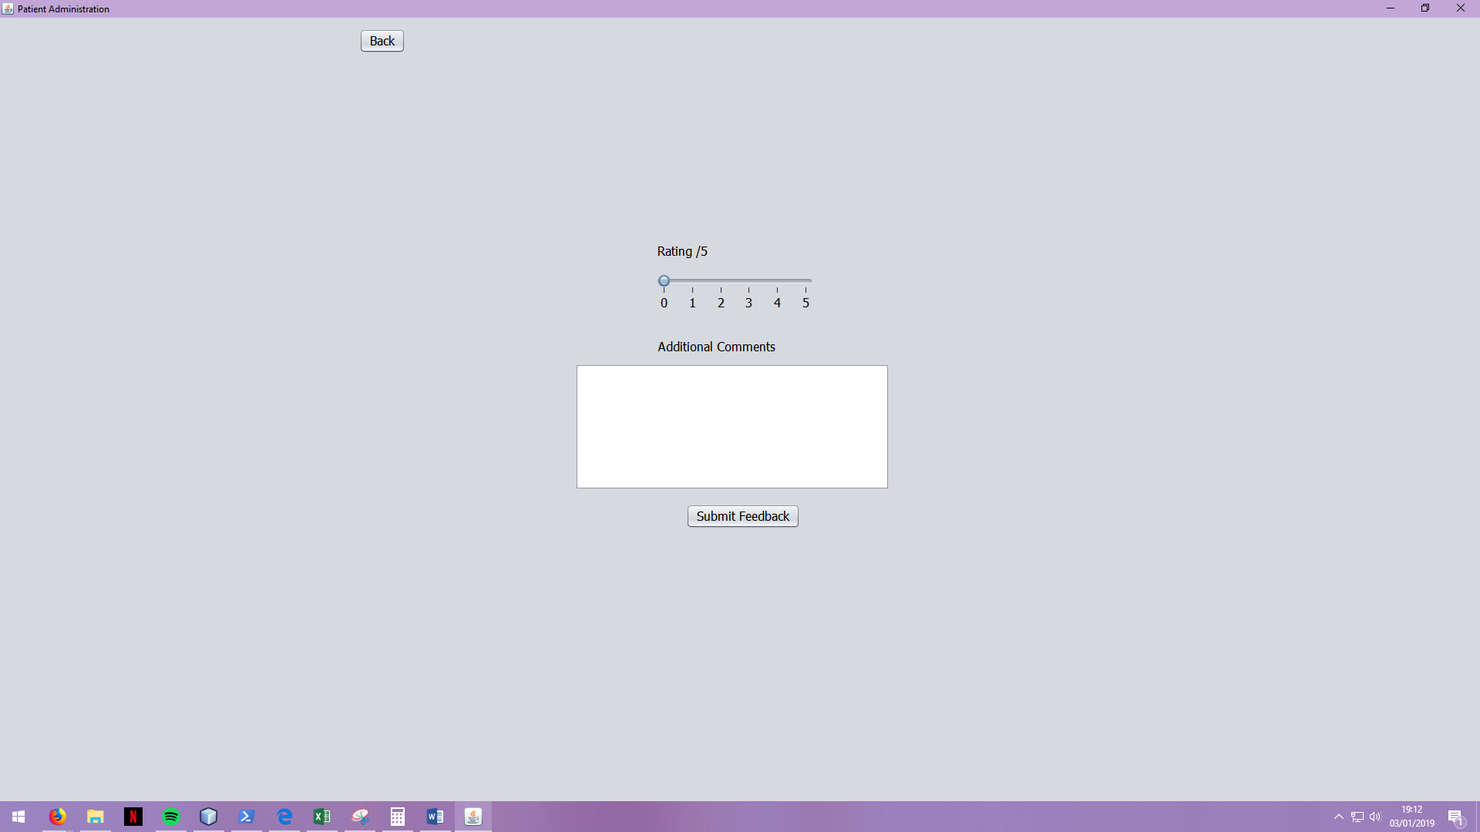

Here they are presented with a simple screen wherein they can offer a rating out of 5 and any additional comments.

## Doctor

Doctors are presented with a much simpler dashboard on login.

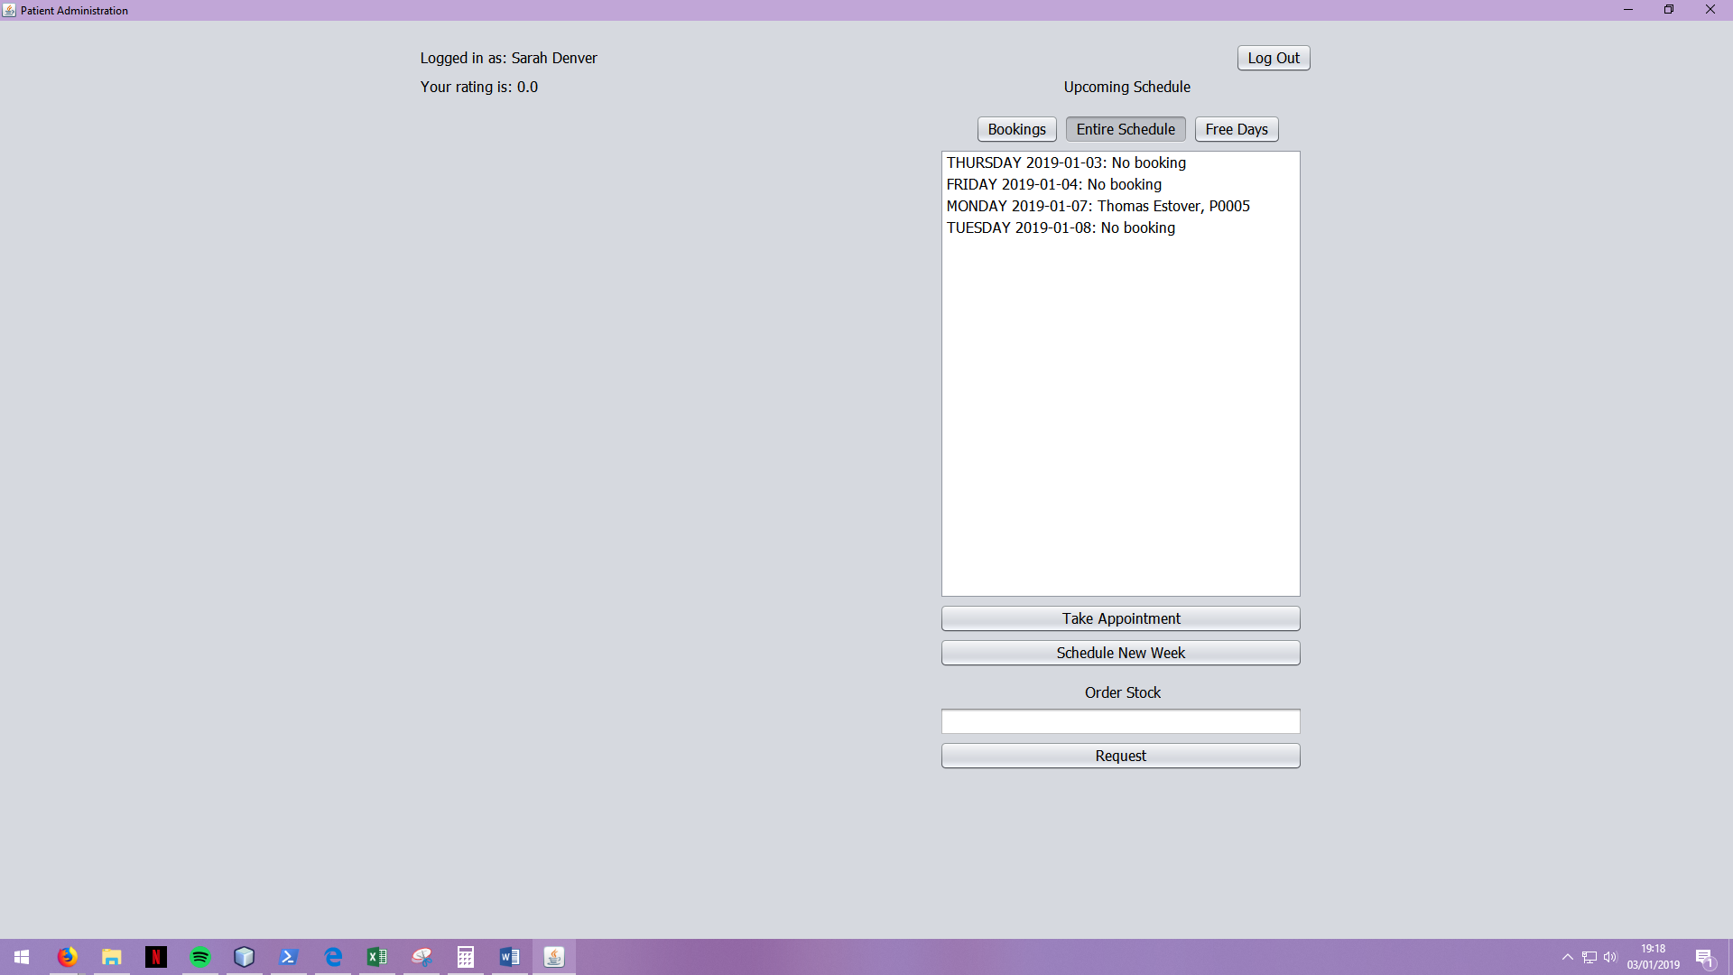

Here they can view their own rating (top left) and availability (right) which can be filtered to avoid confusion. Doctors also always have the option to schedule a new week, which will give them a new week of availability starting on the last day they scheduled.

Additionally, a doctor account can put in a request for new medicines using the simple ui in the bottom corner. All they need to do is enter the name of the medicine they need and submit it, and a request is put forward to the secretaries.

The majority of doctor functionality takes place during a consultation. If they select a date from their availability where they have an active booking, they will be presented with the following:

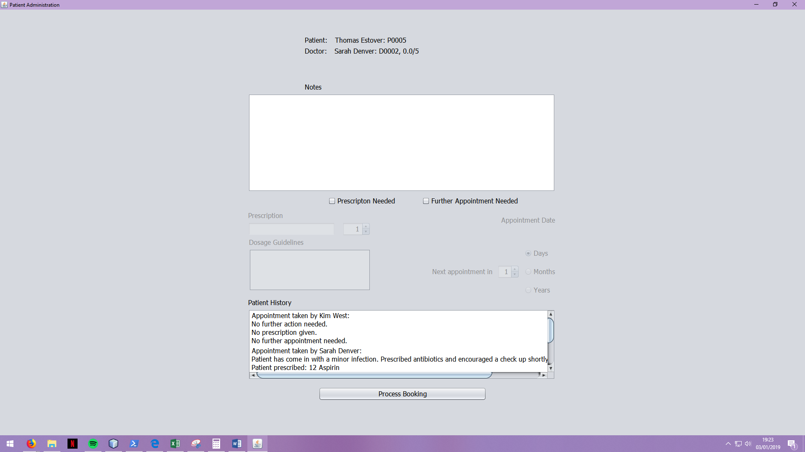

Herein they can make notes during a consultation and decide if a prescription or further appointment are required. If so, they are given logical options to assign information. Below this they can inspect the patient’s history.

Once all information is complete, the doctor can process the appointment and relevant requests for prescriptions and appointments are put forward to secretary accounts.

## Preloaded Accounts

For testing purposes, the following accounts have been created:

|  |  |  |
| --- | --- | --- |
| **Account ID** | **Password** | **Account Type** |
| A0000 | admin | Admin |
| S0001 | josh1 | Secretary |
| D0002 | _sarahdenver | Doctor |
| D0003 | MFennel2 | Doctor |
| D0004 | password1 | Doctor |
| P0005 | Estover2 | Patient |
| P0006 | MiltenMews | Patient |
| P0007 | CathyMill | Patient |

Alternatively, if no data is found then attempting to log in will cause an error but also initialise the default admin account (A0000, admin), so that the admin can log in on their next attempt.